Tanfield Parish Council
Notice of conclusion of audit
Annual Return for the year ended 31 March 2025
Sections 20(2) and 25 of the Local Audit and Accountability Act 2014
Section 16 of the Accounts and Audit Regulations 2015 (Sl 2015/234)
1. The audit of accounts for Tanfield Parish Council for the year ended 31  March 2025 has been completed and the accounts have been published.  - The Annual Return is available for inspection by any local government elector of the area of Tanfield Parish Council on application to:  (a)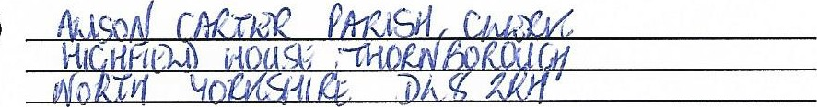  (b) 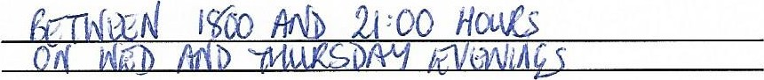  - Copies will be provided to any person on payment of £20 for each copy of the Annual Return. To any local Government Elector of the area.  Announcement made by: (d)Alison Carter, Parish Clerk  Date of announcement: (e) 26092025 | Notes  This notice and Sections 1, 2 & 3 of the Annual Retum must be published by 30 September. This must include publication on the smaller authority's website.  - Insert the name, position and address of the person to whom local government electors should apply to inspect the Annual Return  - Insert the hours during which inspection rights may be exercised  - Insert a reasonable sum for copying costs  - Insert the name and position of person placing the notice  - Insert the date of placing of the notice

